MULTI WORDPRESS SETUP IN Amazon RedHat 7 Instance.

For Ubuntu <https://www.rosehosting.com/blog/how-to-install-wordpress-with-lamp-stack-on-ubuntu-18-04/>

Before multi sitewordpress setup we have to install Apache, Mysql, PHP and WordPress. Below step are showed installing above packages to run wordpress as follows.

1. Installing Apache

Before Installing apache you have to be super user

#sudosu –

#yum update –y

#yum install httpd –y

#service httpd start

#service httpd status

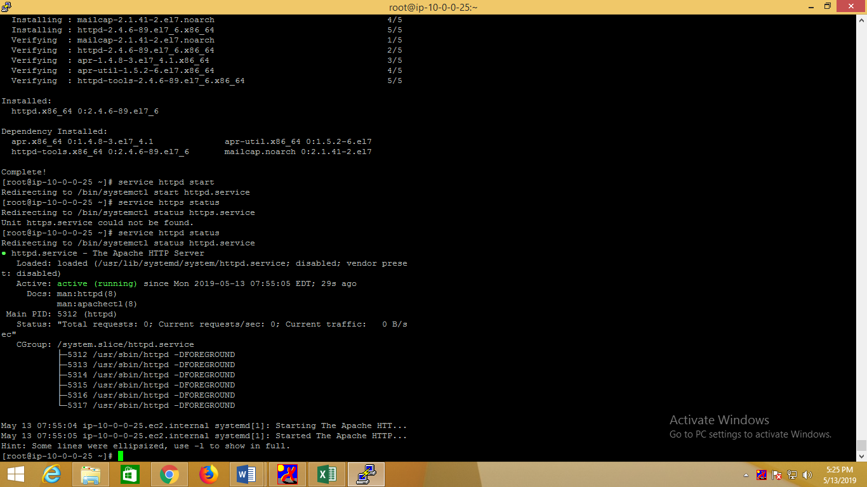

Now check with public IP Address in browser

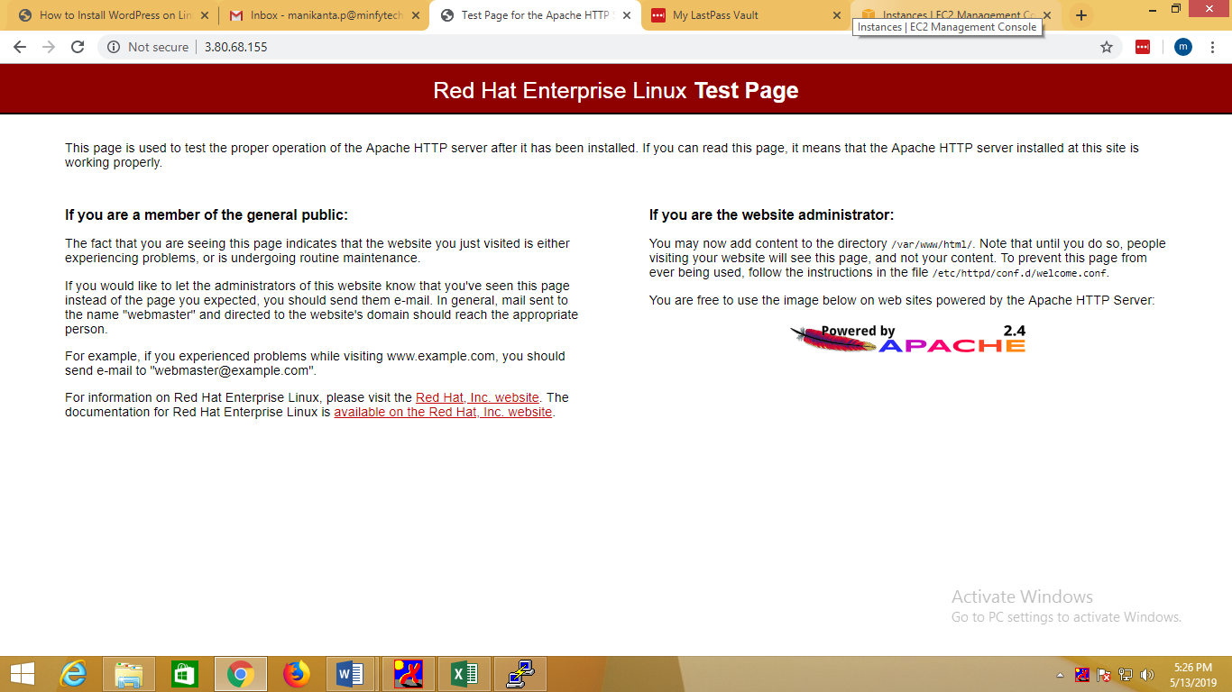

**Now Install MYSQL**

# yum update

#yum install wget

Download and add the repository, then update.

#wget<http://repo.mysql.com/mysql-community-release-el7-5.noarch.rpm>

# rpm -ivh mysql-community-release-el7-5.noarch.rpm

# yum update

Install MySQL as usual and start the service.

#yum install mysql-server

# systemctl start mysqld

Run the mysql_secure_installation script to address several security concerns in a default MySQL installation.

#mysql_secure_installation

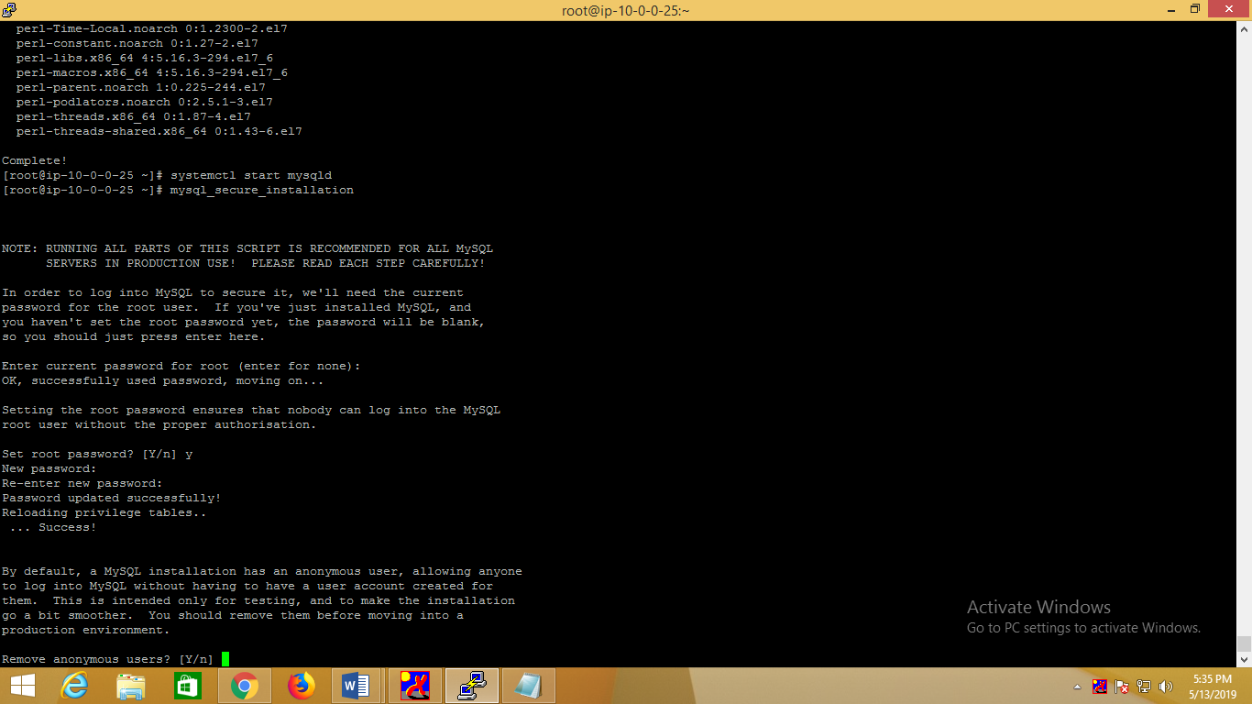

After entered above command, you seen Enter currebt password for root just press Enter button, and press ‘Y’ for set root password this password you have to remember, because it uses in further cases.

Now Entering to log in to MySQL as the root user:

#mysql –u root –p

When prompted, enter the root password you assigned when the mysql_secure_installation script was run.

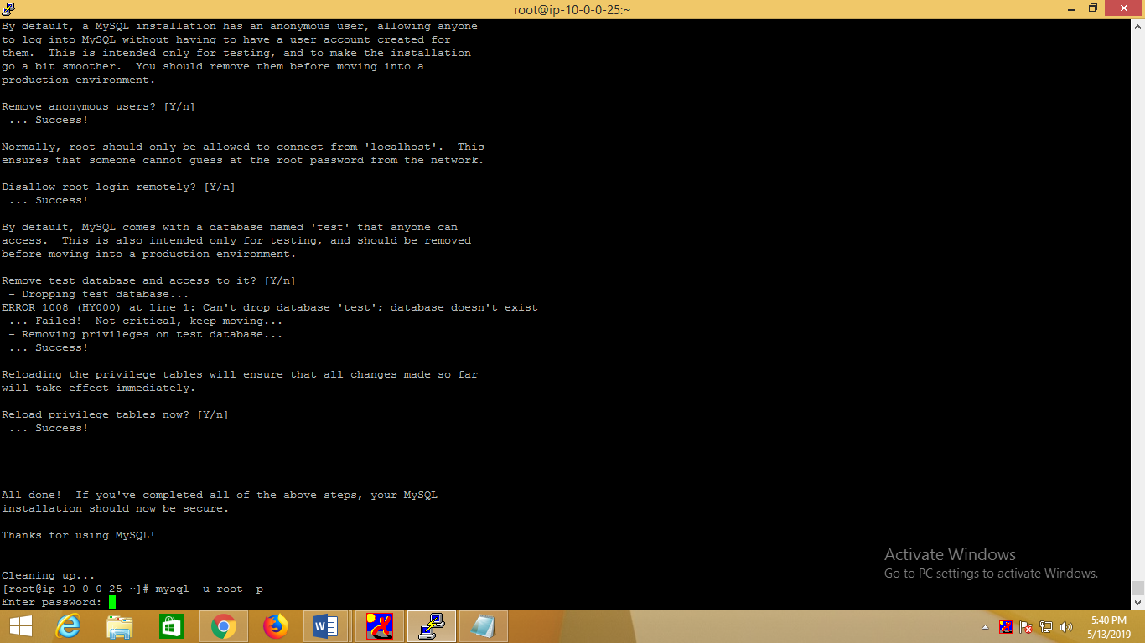

After given password

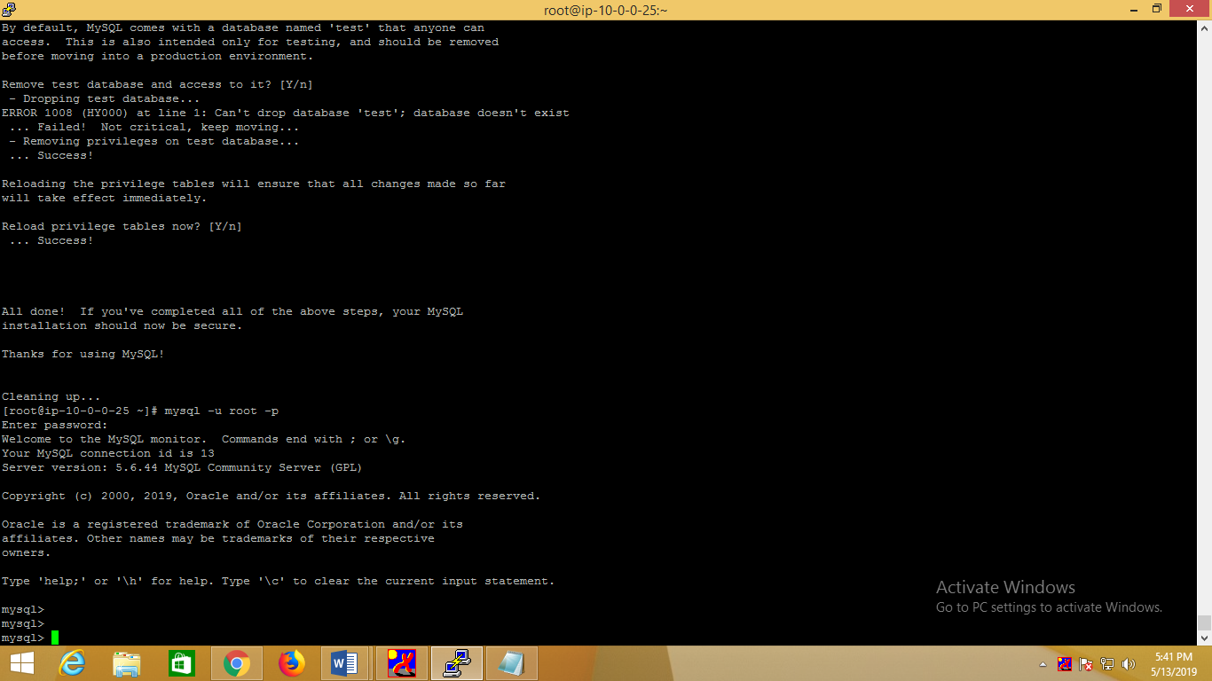

Now, We need a database and an user in that database.

Here we create database, user and password and grant all privileges to particular user, At last, refresh MySQL and exit.

How to check mysql service status

#service mysqld status

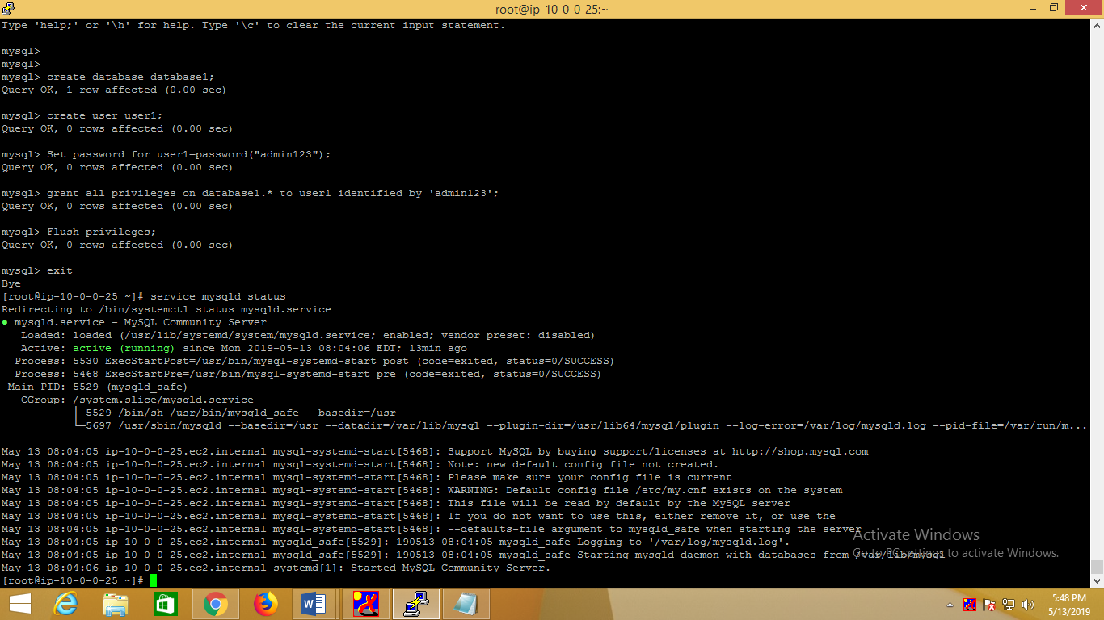

**Now installing PHP-7 version**

 To install **PHP**, you have to install and enable **EPEL** and **Remi** repository to your OS system using the commands below.

# yum install <https://dl.fedoraproject.org/pub/epel/epel-release-latest-7.noarch.rpm>

# yum install <http://rpms.remirepo.net/enterprise/remi-release-7.rpm>

install **yum-utils** which is an assortment of utilities that integrate with yum to enhance its default features

#yum install yum-utils

One of the most important program provided by **yum-utils** is **yum-config-manager**, which you can use to active **Remi** repository as the default repository for installing various PHP versions. For example, if you want to install **PHP 7.2**

**#yum-config-manager --enable remi-php72**

Now that you’ve enabled selected versions of PHP, you can install PHP

#yum-config-manager --enable remi-php72

# yum install php php-mcrypt php-cli php-gd php-curl php-mysql php-ldap php-zip php-fileinfo

check the installed version of PHP on your system.

#php –v

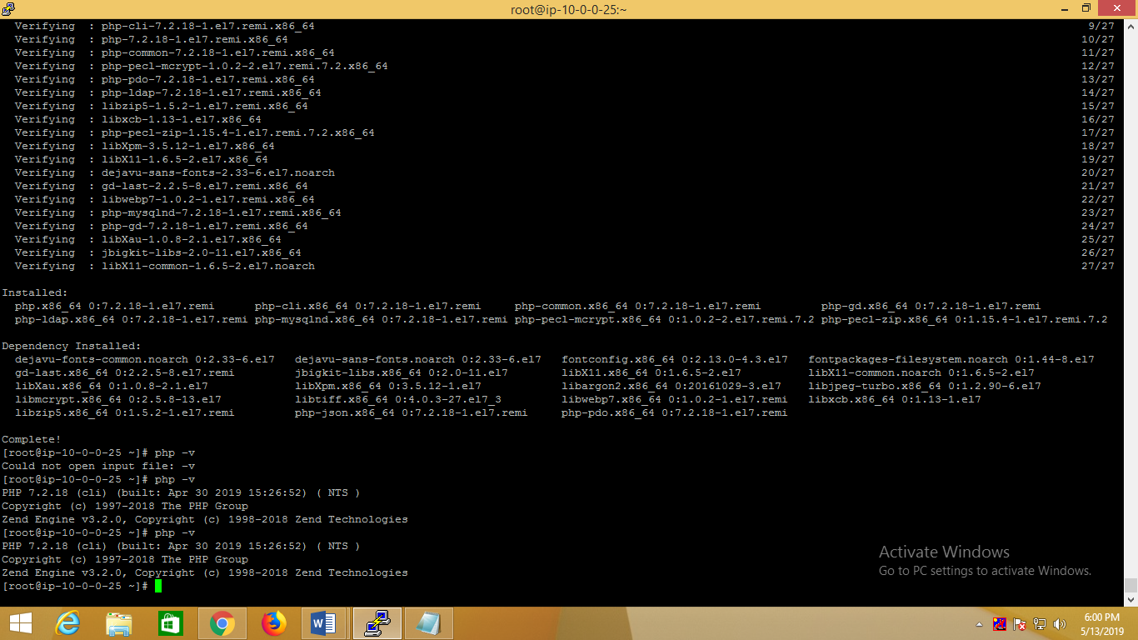

Sucessfullyphp 7.2 version installed.

How to setup WordPress.

#wget<http://wordpress.org/latest.tar.gz>

Unzip the compressed file into the desired location.

#tar -xvzf latest.tar.gz

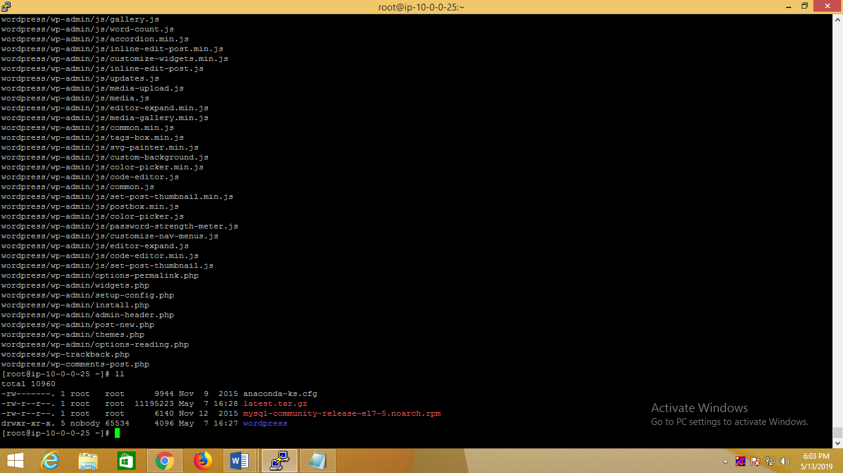

When you unzip the file successfully one directory will appear name called ‘Wordpress’ as shown above picture.

Creating MySQL User and database for WordPress-

Login to MySQL Shell:

# mysql –u root –p

#create database database1;

# create user user1;

#Set password for user1=password("admin123");

Now, provide all **privileges** to this new user.

#grant all privileges on database1.* to user1 identified by 'admin123';

At last, refresh MySQL:-

#Flush privileges;

#exit

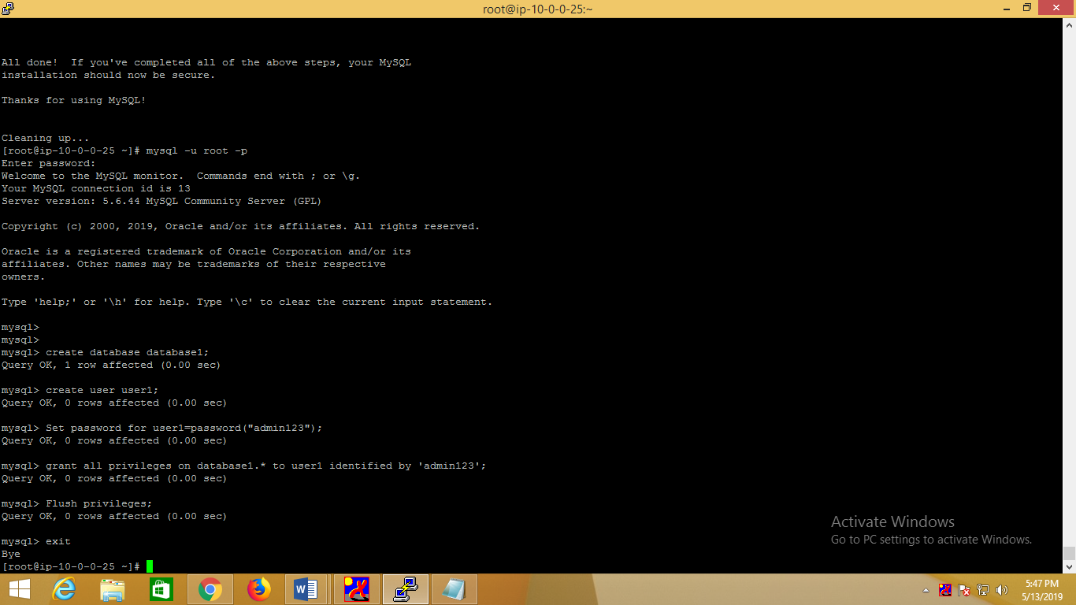

#ls –for list

Now gotowordpress directory by using cd command

# cdwordpress

#ll

List showed all which are present in wordpress

# Copy **wp-config-sample.php** to **wp-config.php**

Open**wp-config.php,**update the **database, user, and**its**password using vi editor**

**#**viwp-config.php

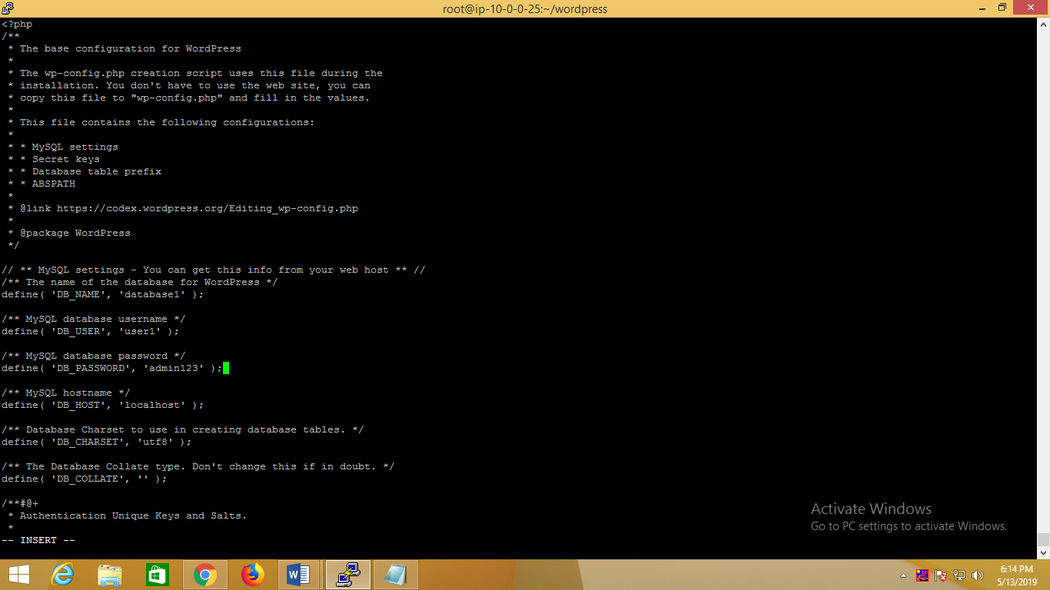

Now Save and exit from vi editor

Copy this WordPress directory into Server

#cp -r ~/wordpress/* /var/www/html

Download php-gd, if the form does require a specific php module to run and is not yet installed on your server.

Next restart Apache services.

# servicehttpd restart

If you want you can restart the mysql service also.

# servicemysqld restart

#cd /var/www/html

#ll

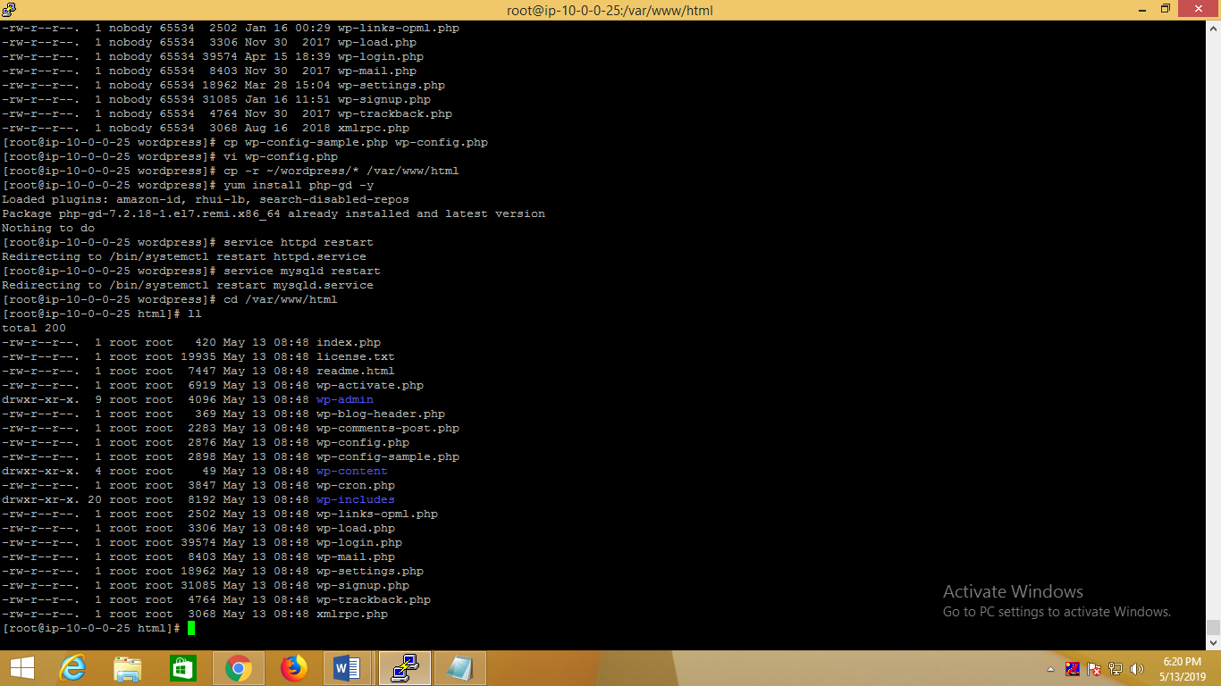

These are the list are appear

In that info.php file has to be create by using vi editor

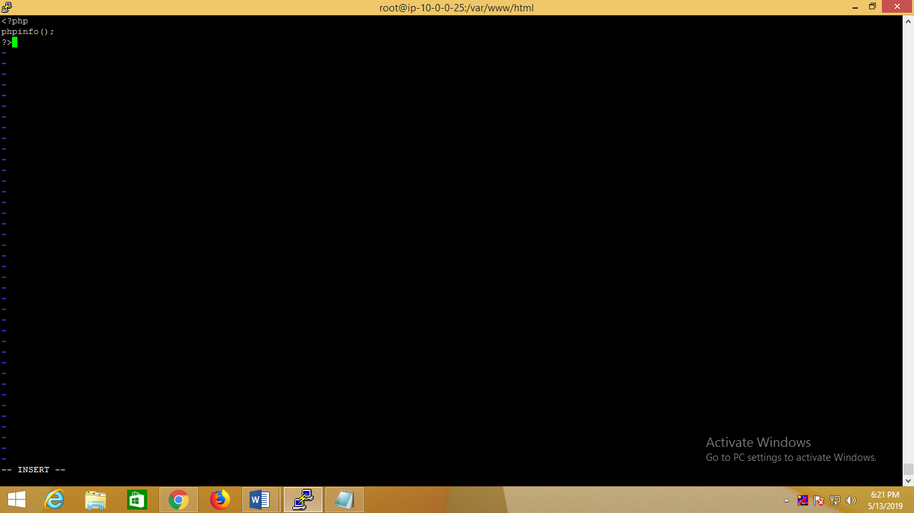

Save and exit “Esc :wq”

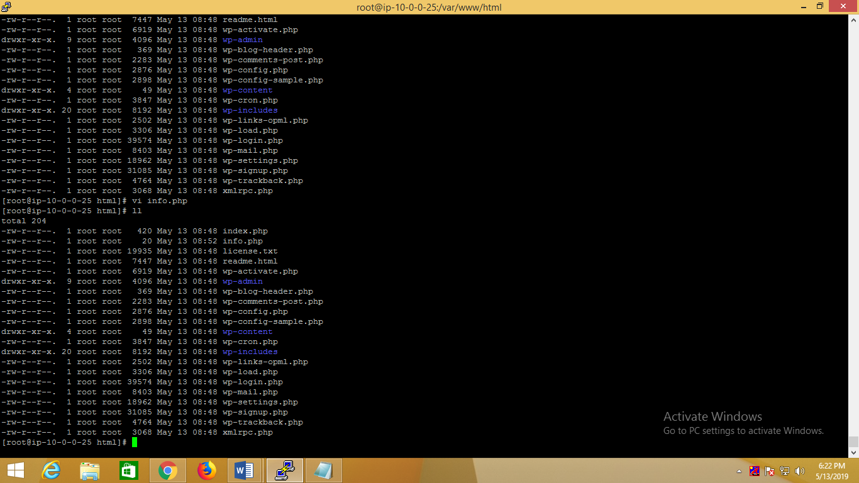

Info.php has added, now check in browser weather php page will occur or not example<http://IPAddress/info.php>

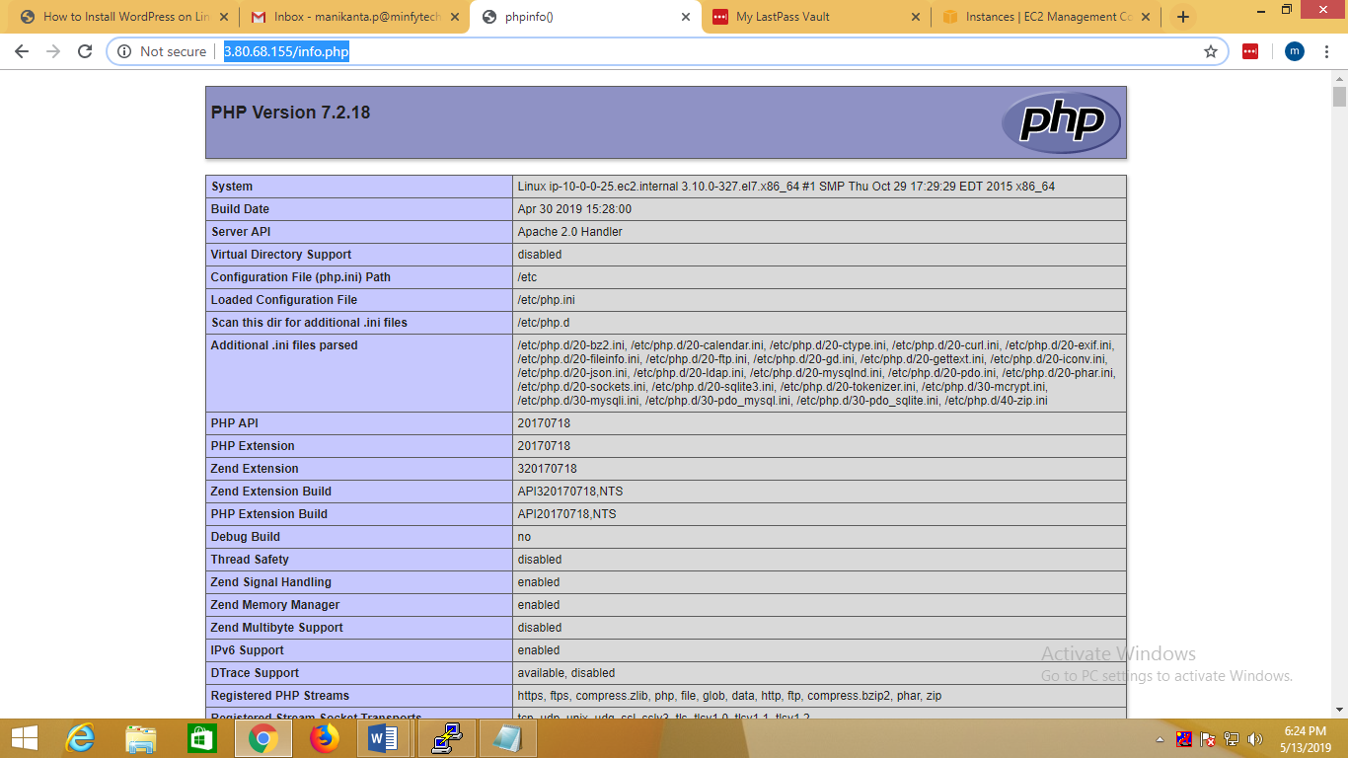

Now we can check Wordpress installed or not by using through below url

<http://IPAddress/wp-admin>

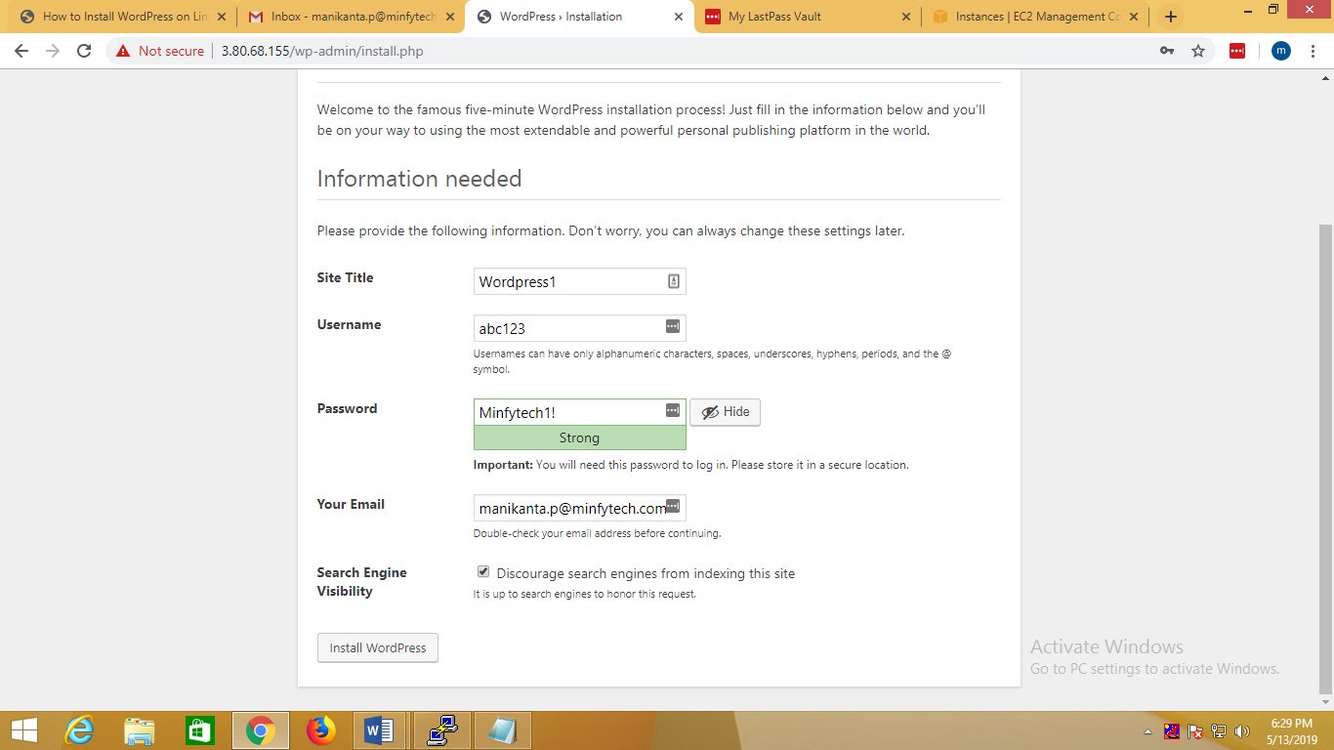

Press install wordpress

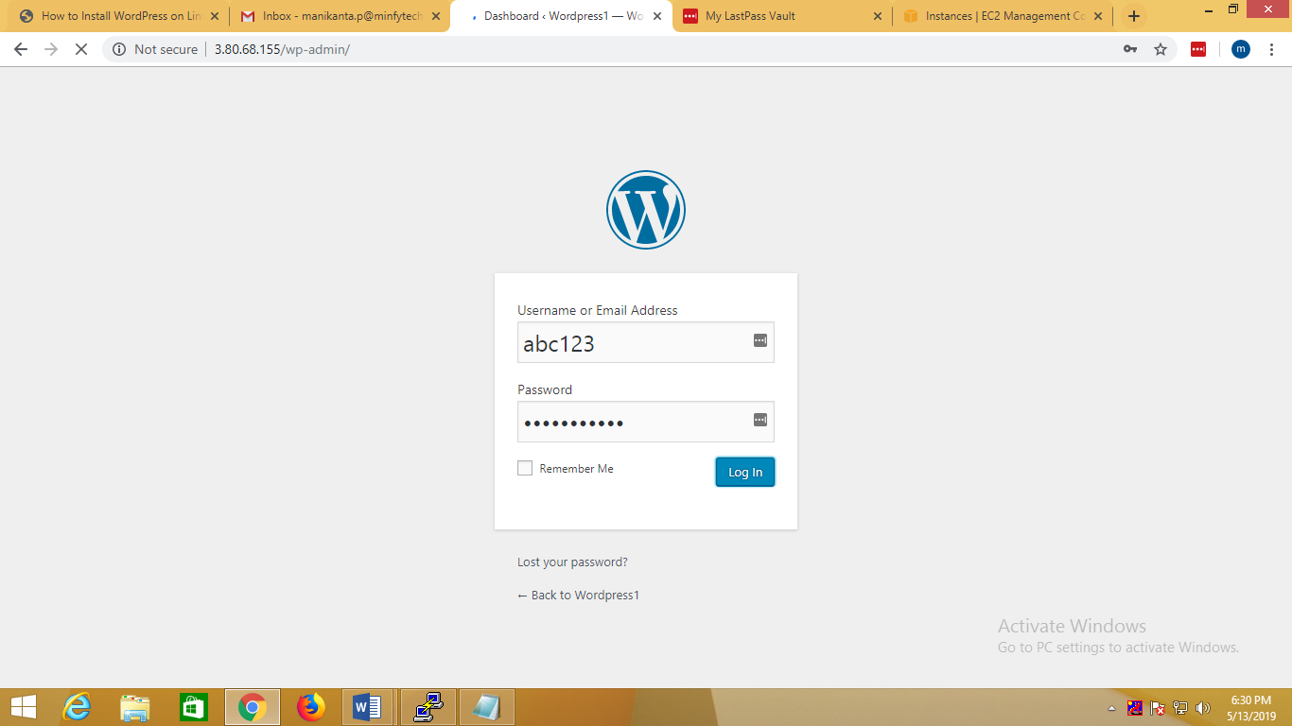

You have to login here

Now select theme and activate

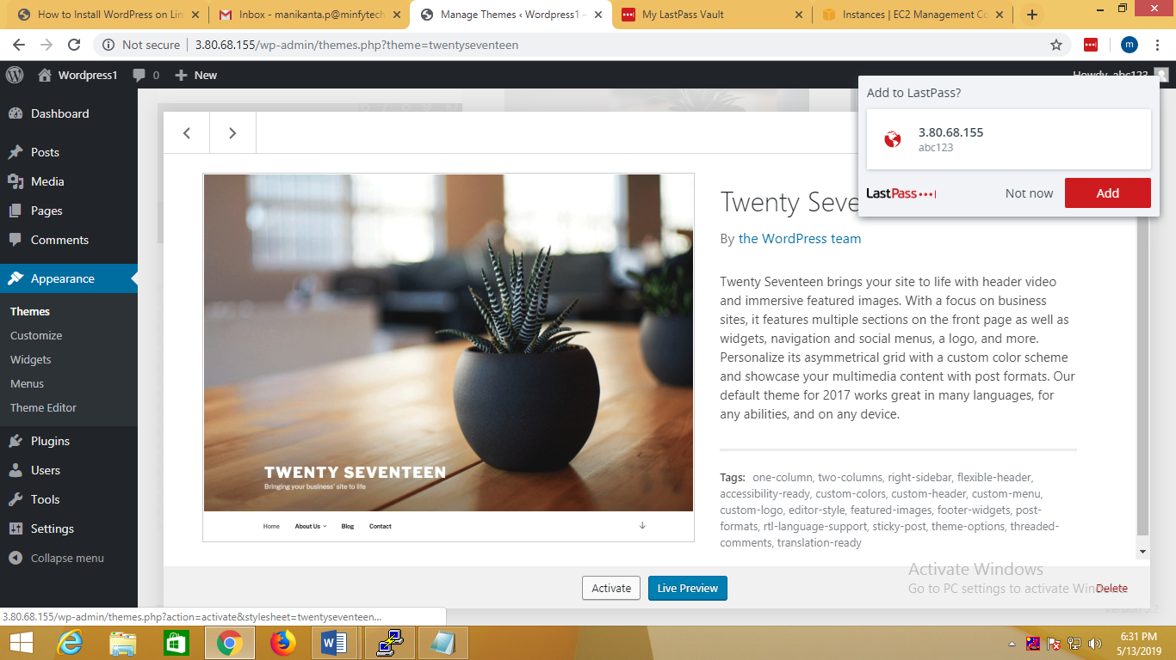

Now logout and again check through ipaddress if selected theme is appearing or not

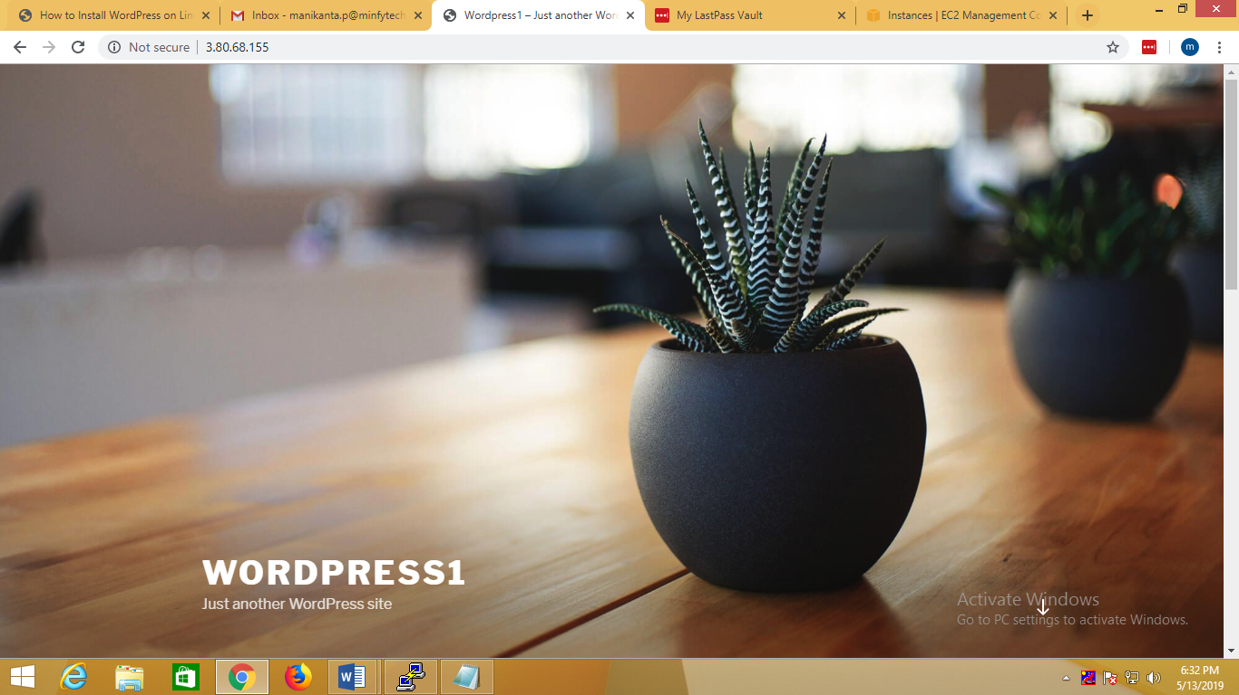

Successfully wordpress one path completed

How to host multiple sites in a single Wordpress installation

You have to create database in mysql prompt, exactly same before what we done, just change the names.

Login to MySQL Shell:

# mysql –u root –p

#create database database2;

# create user user2;

#Set password for user2=password("admin123");

Now, provide all **privileges** to this new user.

#grant all privileges on database2.* to user2 identified by 'admin123';

At last, refresh MySQL:-

#Flush privileges;

#exit

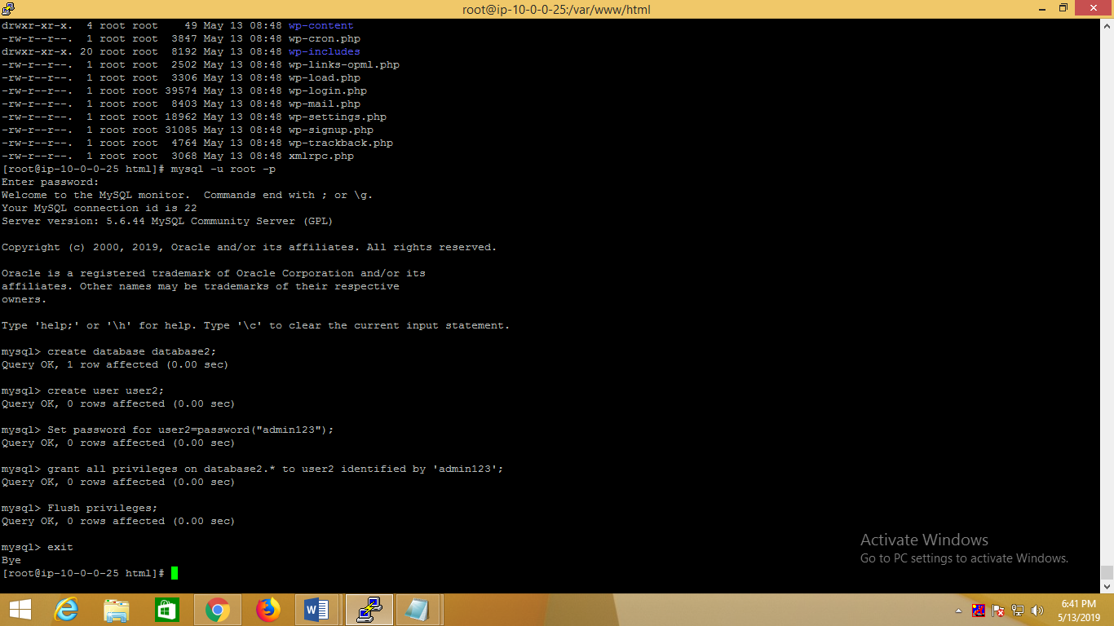

Now restart both services mysql and httpd.

#service httpd restart

#service mysqld restart

Installation of WordPress

We will first make a directory ‘temp’ in which I will the download the latest version of the WordPress as follows:

# mkdir temp

# cd temp

# yum install wget unzip net-tools

# wget<http://wordpress.org/latest.zip>

#yum install php-gd

#service httpd restart

unzip the Wordpress 4.0 zip file in the folder:

# unzip -q latest.zip -d /var/www/html/

Now give appropriate permissions in the directory

# chown -R apache:apache /var/www/html/wordpress

# chmod -R 755 /var/www/html/wordpress

Further we need to manually create the uploads directory beneath the wp-content directory at our document root. This will be the parent directory of our content:

# mkdir -p /var/www/html/wordpress/wp-content/uploads

We need to allow the web server itself to write to this directory. We can do this by assigning group ownership of this directory to our web server. This will allow the web server to create files and directories under this directory, which will permit us to upload content to the server. Proceed like this:

# chown -R :apache /var/www/html/wordpress/wp-content/uploads

Now we need the sample configuration file,to copy it to the default configuration file to get WordPress to recognize the file. The sample configuration file is available at */var/www/html/wordpress*:

#cd /var/www/html/wordpress/

#cp wp-config-sample.php wp-config.php

#viwp-config.php

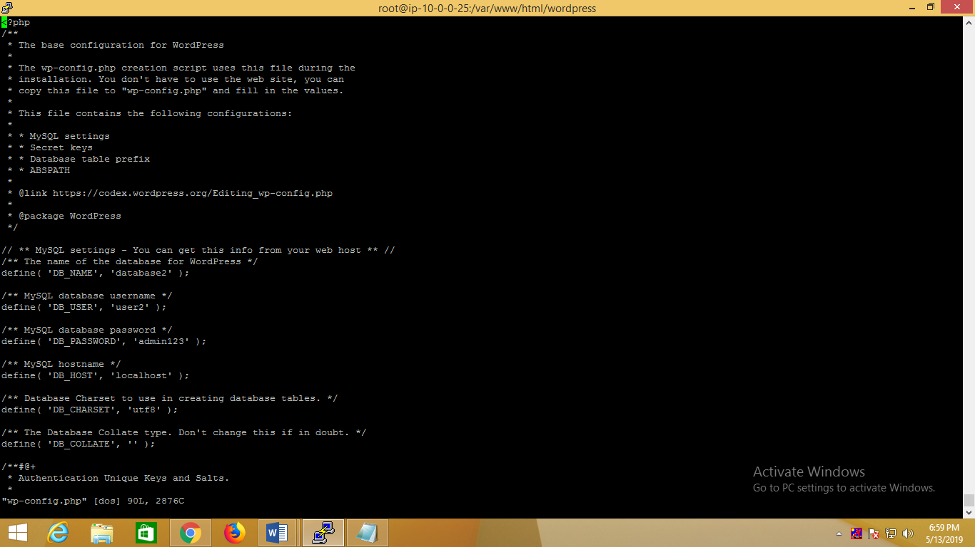

**Multiple site configuration**

Now we will proceed with the multiple site configuration, for this we need to add these lines to our *wp-config.php*

**[...]**

**/* Multisite */**

**define('WP_ALLOW_MULTISITE', true);**

**/* That's all, stop editing! Happy blogging. */**

**[...]**

**You can add that in last line**

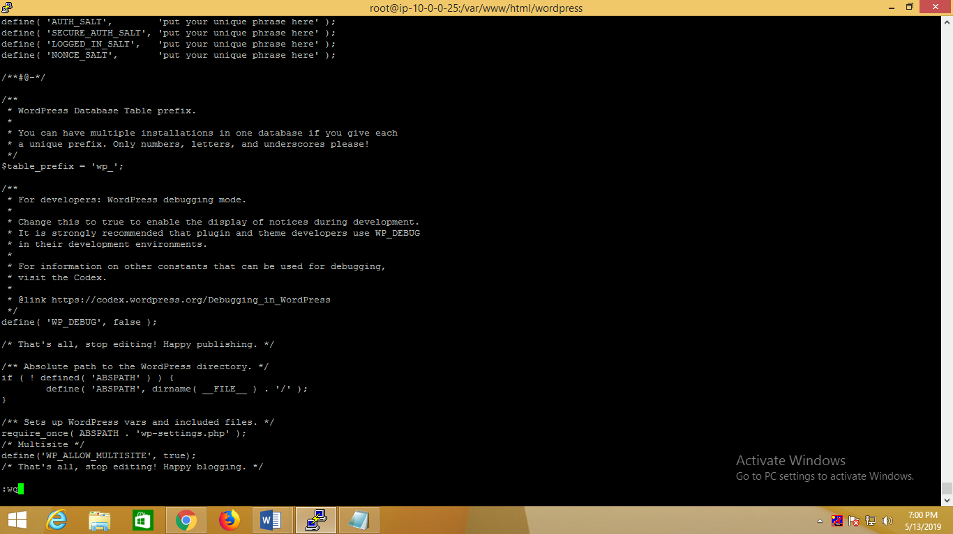

**Apache Rewrite:**

We will modify the apache virtual host file for WordPress to get it allowed for *.htaccess* overrides. For this we will edit the virtual host file and add the entries as:

# vi /etc/httpd/conf/httpd.conf

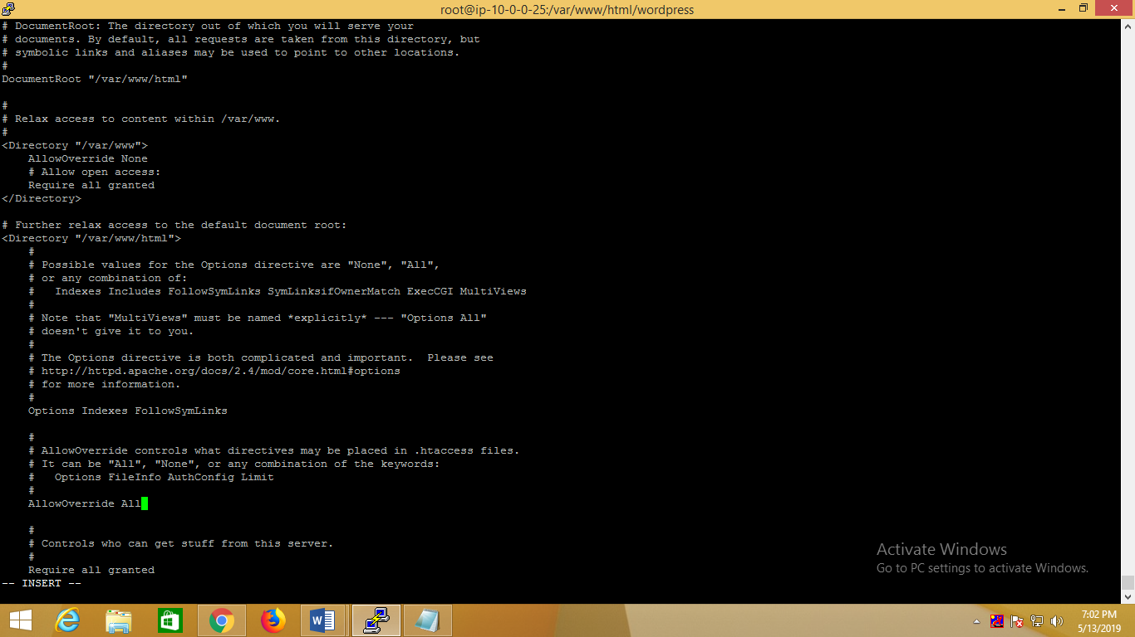

Change the value from *AllowOverride None* to *AllowOverride All*, next restart the service:

#service httpd restart

**Create an .htaccess File:**

Now we will create .htaccess file in document root, it will allow Apache to rewrites:

#touch /var/www/html/wordpress/.htaccess

We need the web server to be the group owner though, so we should adjust the ownership as follows:

#chown apache /var/www/html/wordpress/.htaccess

If you want WordPress to automatically update this file with rewrite rules, you can ensure that it has the correct permissions to do so by using:

#chmod 664 /var/www/html/wordpress/.htaccess

Webinstallation:

Now proceed to the web installation of WordPress 4.0. Go to the URL <http://192.168.0.100/wordpress/wp-admin>

Select language and press Continue:

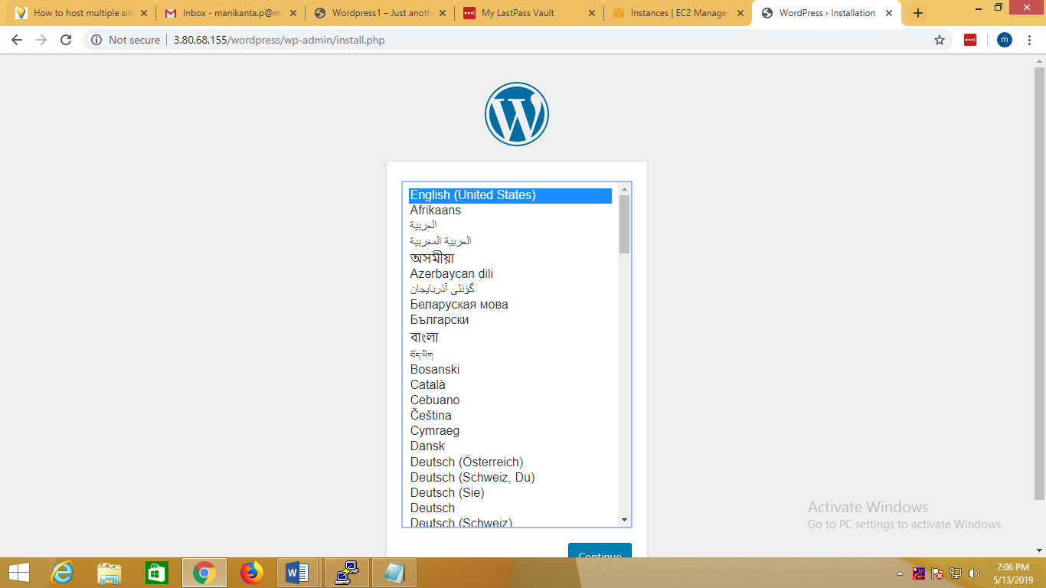

Enter your information:

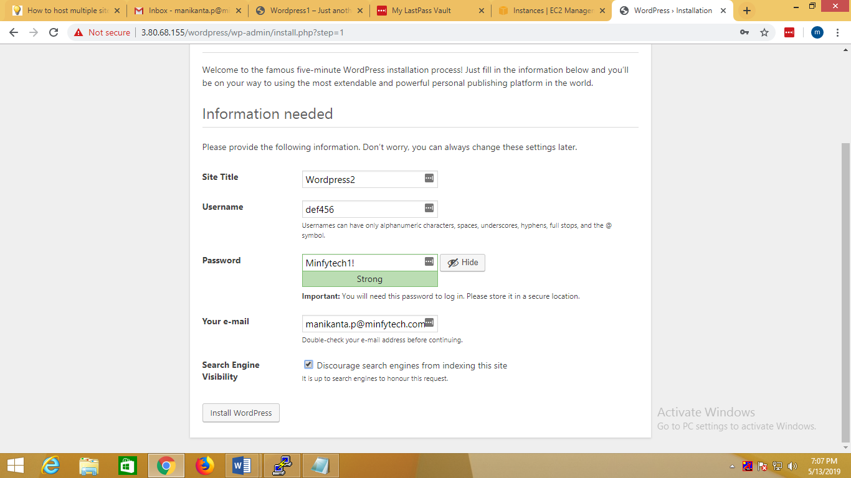

Press install wordpress button.

You have to login here:

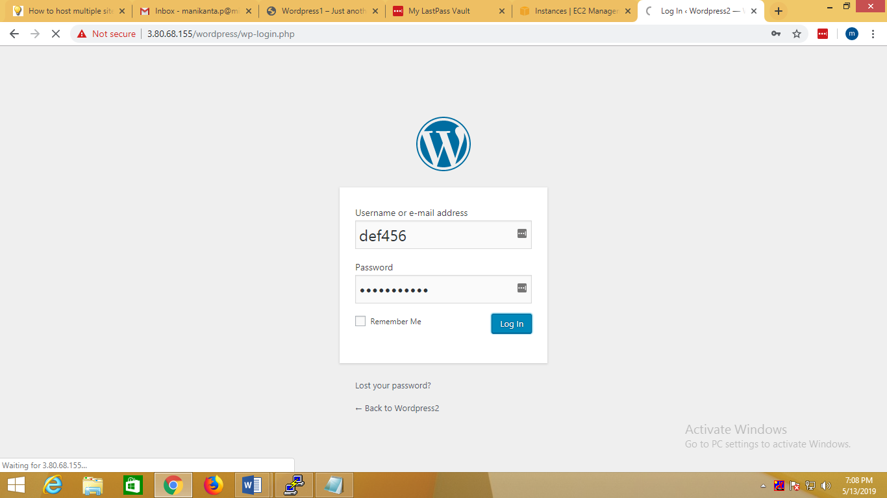

Select theme and activate:

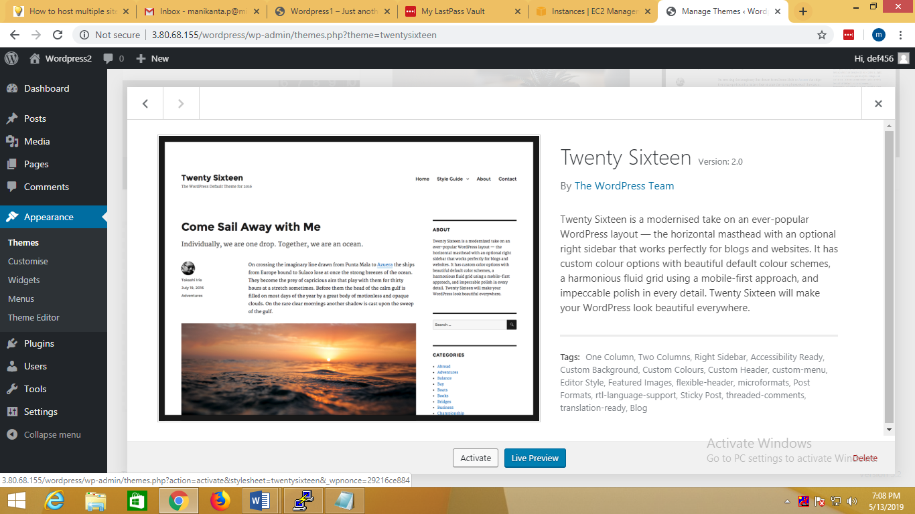

And logout.

Now we have multi sitewordpress in two fifferent paths

1. <http://ipaddress/wp-admin> (one path wordpress login page)
2. <http://ipaddress/wordpress/wp-admin> (second path for wordpress login page)

Through this we can successfully created two different paths wordpress installations.